BANK LOAN CASE STUDY

Data Analytics Tasks:
A. Identify Missing Data and Deal with it Appropriately: As a data analyst, you come across missing data in the loan application dataset. It is essential to handle missing data effectively to ensure the accuracy of the analysis.
- Task: Identify the missing data in the dataset and decide on an appropriate method to deal with it using Excel built-in functions and features.
- Hint: Utilize Excel functions like COUNT, ISBLANK, and IF to identify missing data. Consider using functions like AVERAGE or MEDIAN for imputation or other appropriate methods available in Excel.
- Graph suggestion: Create a bar chart or column chart to visualize the proportion of missing values for each variable.

Deleted Columns- Columns which has more than 50% null or blanks are deleted which does not give much information such as-

FONDKAPREMONT_MODE, HOUSETYPE_MODE, WALLSMATERIAL_MODE, AMT_REQ_CREDIT_BUREAU_HOUR, AMT_REQ_CREDIT_BUREAU_DAY, AMT_REQ_CREDIT_BUREAU_WEEK, AMT_REQ_CREDIT_BUREAU_MON, AMT_REQ_CREDIT_BUREAU_QRT, AMT_REQ_CREDIT_BUREAU_YEAR, APARTMENTS_AVG, APARTMENTS_MODE, APARTMENTS_MEDI, BASEMENTAREA_AVG, BASEMENTAREA_MODE, BASEMENTAREA_MEDI, YEARS_BEGINEXPLUATATION_AVG, YEARS_BEGINEXPLUATATION_MODE AND SO ON……………

============================================================
Some of them are kept to analyze the data

OCCUPATION_TYPE-30% missing
EXT_SOURCE_1-56% missing
TOTALAREA_MODE-50% missing

Filling the blank spaces-
The numerical columns are filled with median and the categorical data with Mode

Amt Annuity column is filled with median
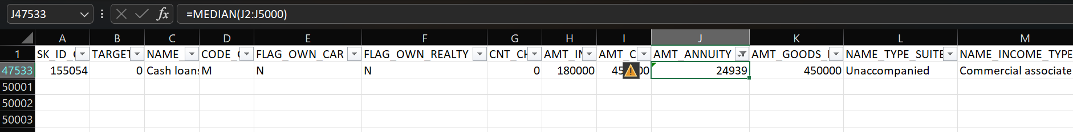
Median

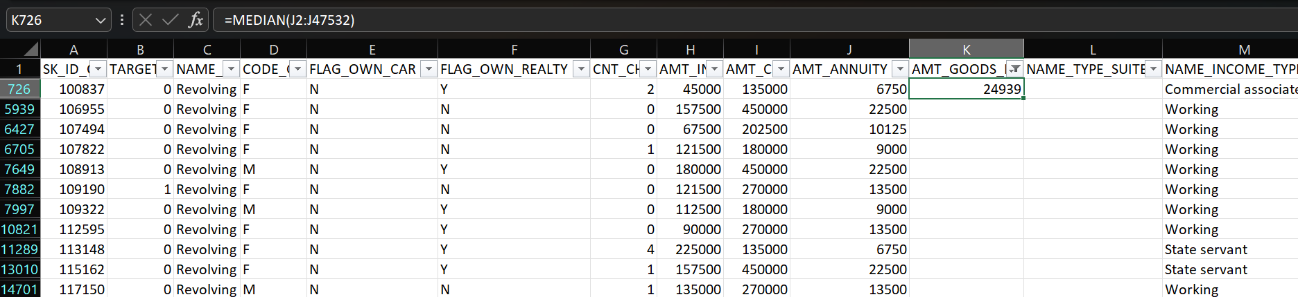
Mode
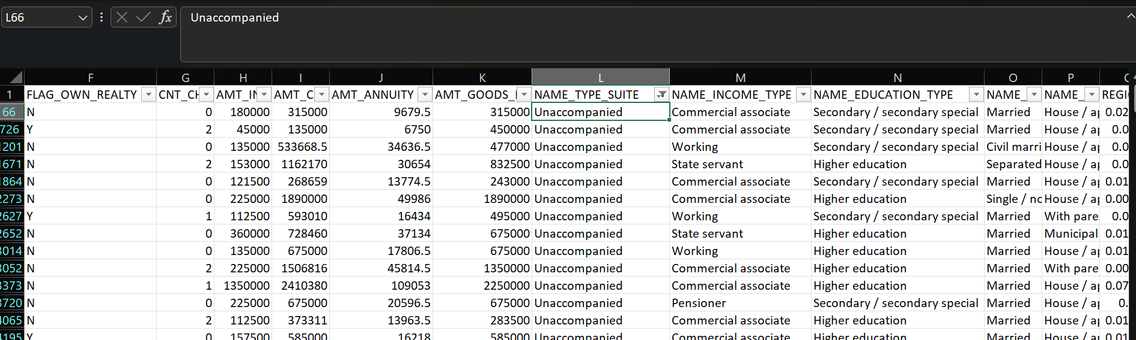

Median
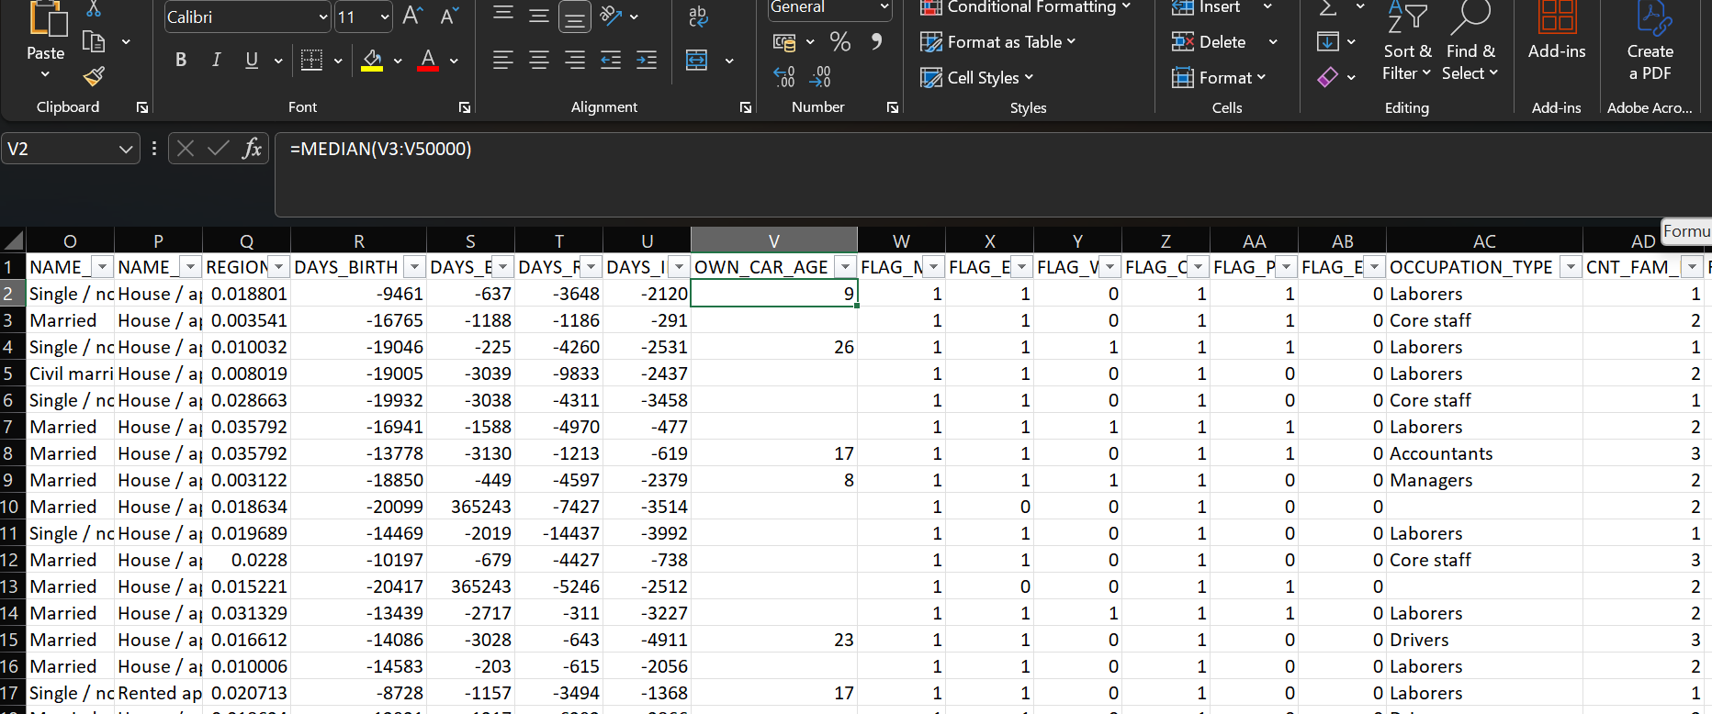

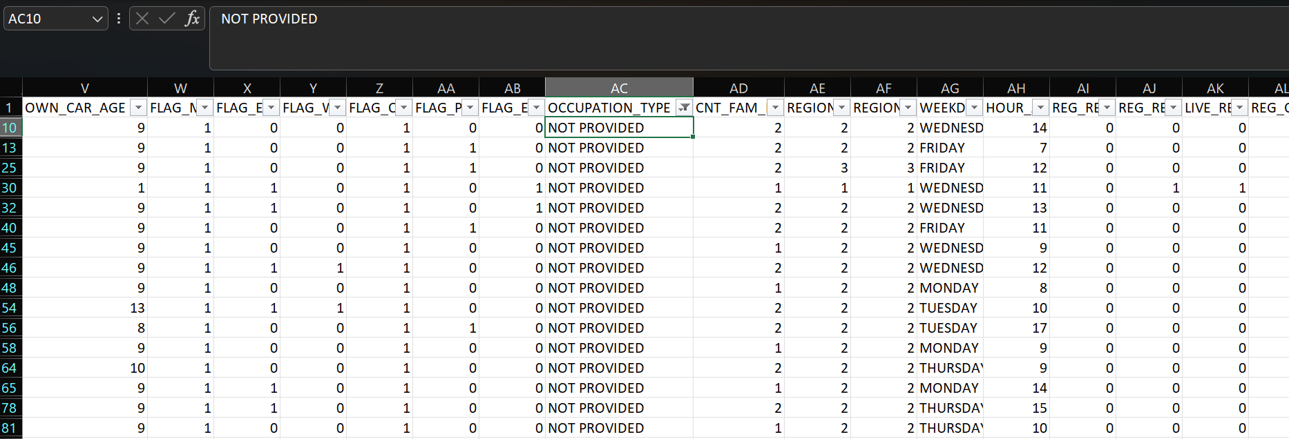

Median
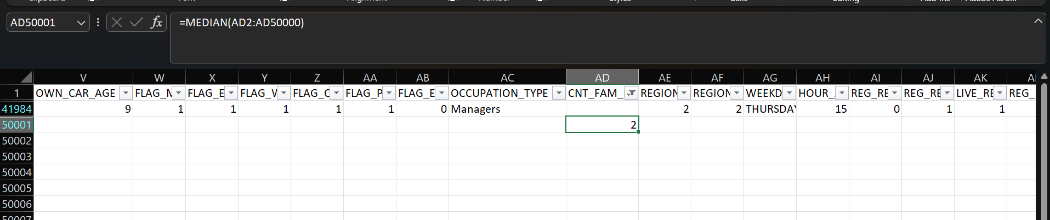
Median
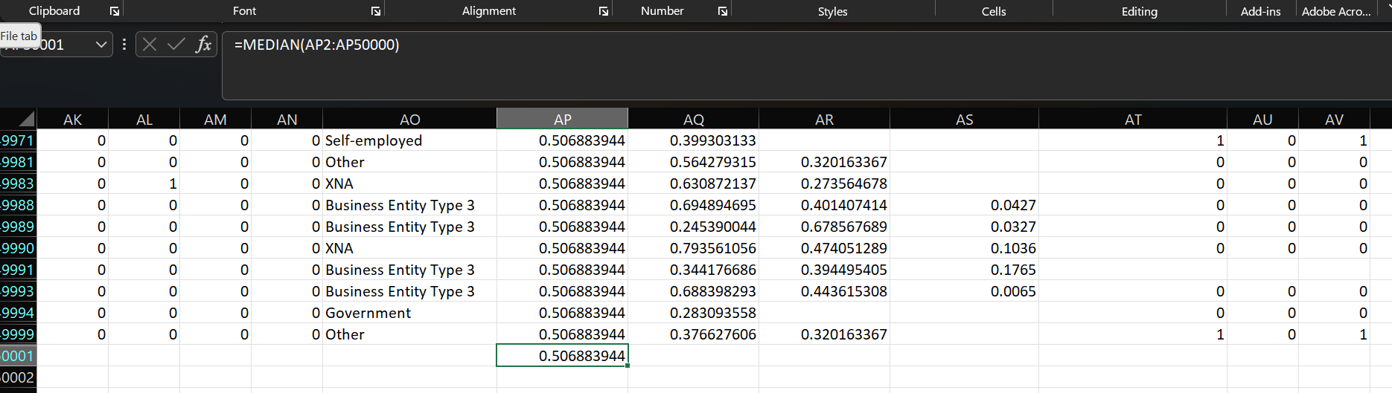

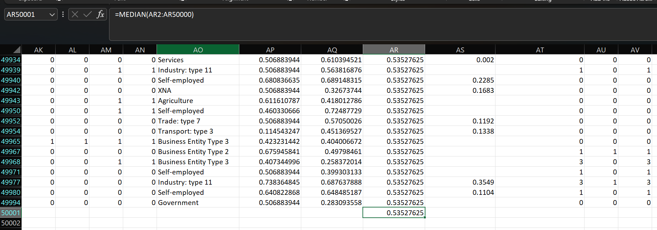

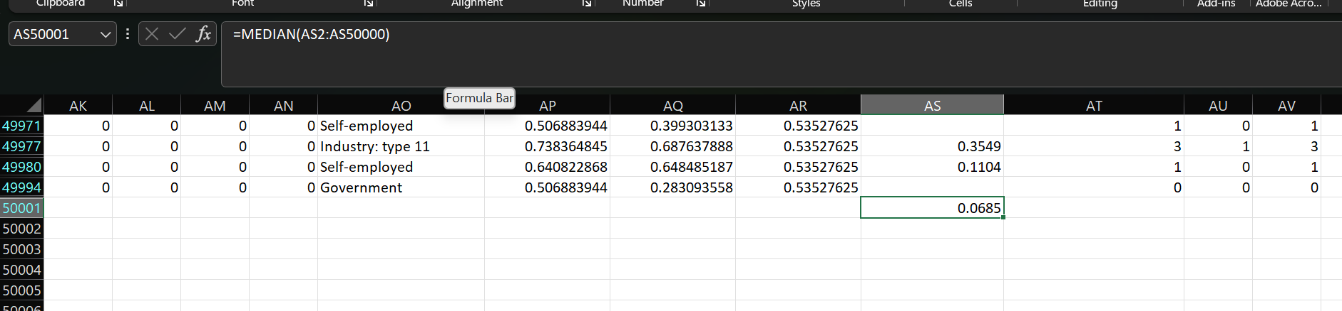

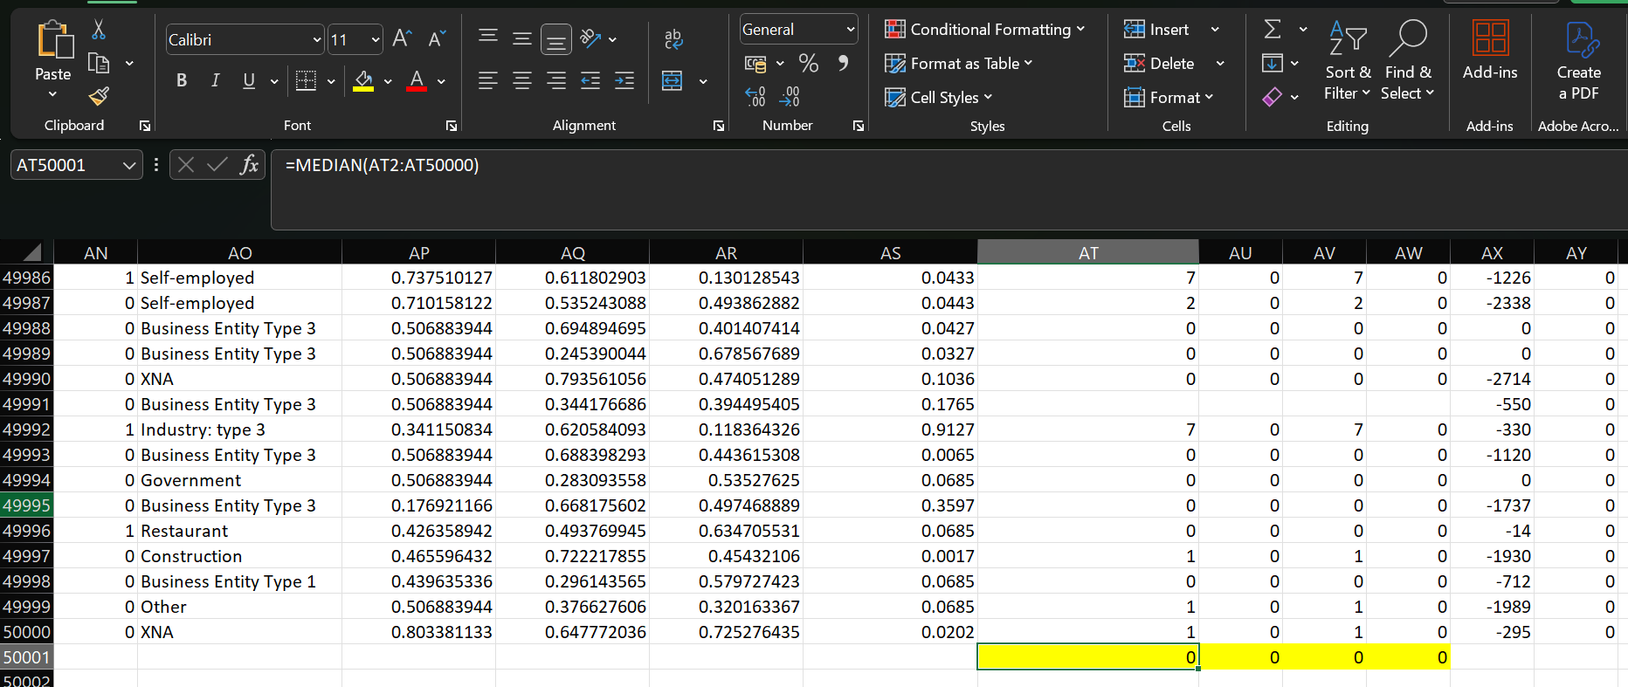

Merge the data for future use

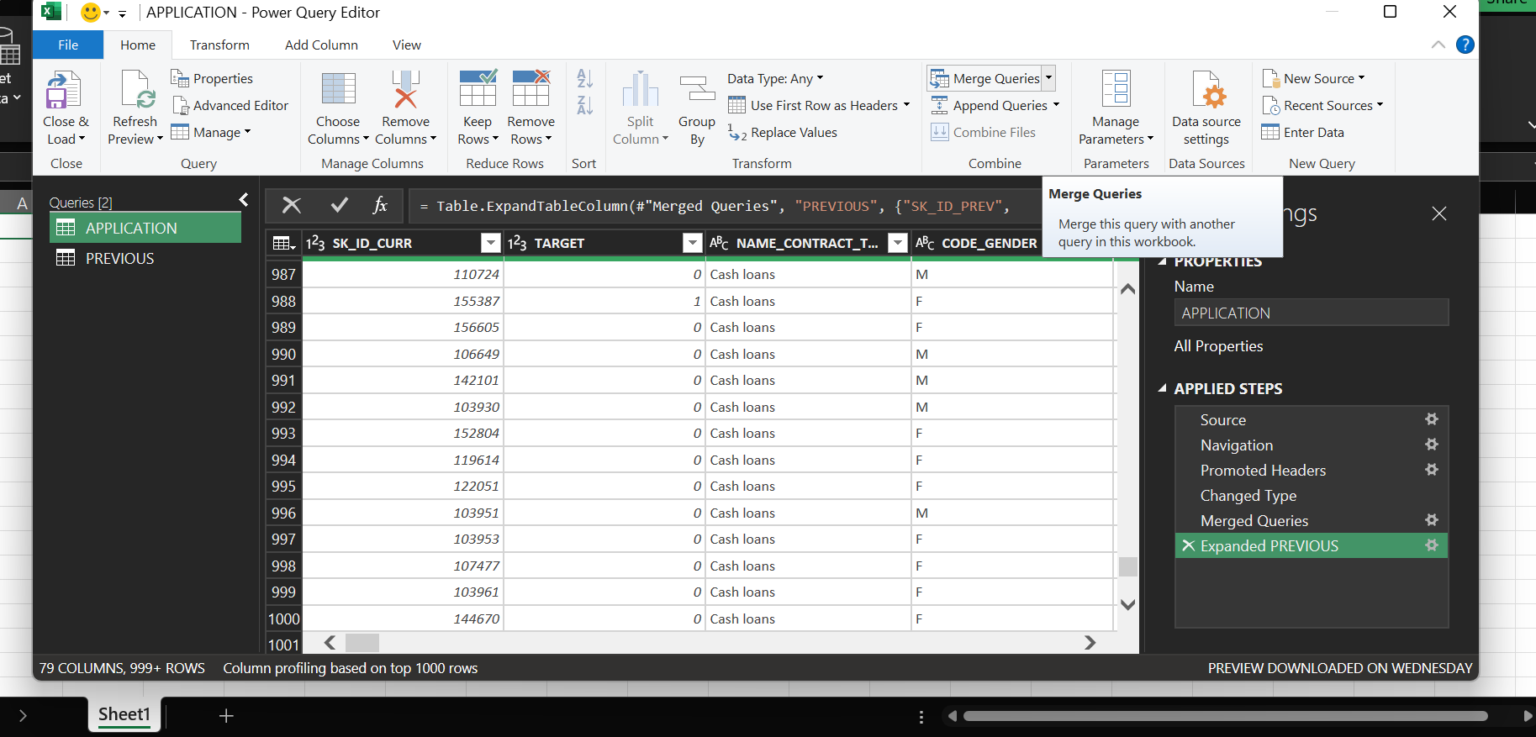

B. Identify Outliers in the Dataset: Outliers can significantly impact the analysis and distort the results. You need to identify outliers in the loan application dataset.
- Task: Detect and identify outliers in the dataset using Excel statistical functions and features, focusing on numerical variables.
- Hint: Utilize Excel functions like QUARTILE, IQR, and conditional formatting to identify potential outliers. Consider applying thresholds or business rules to determine if the outliers are valid data points or require further investigation.
- Graph suggestion: Create box plots or scatter plots to visualize the distribution of numerical variables and highlight the outliers.
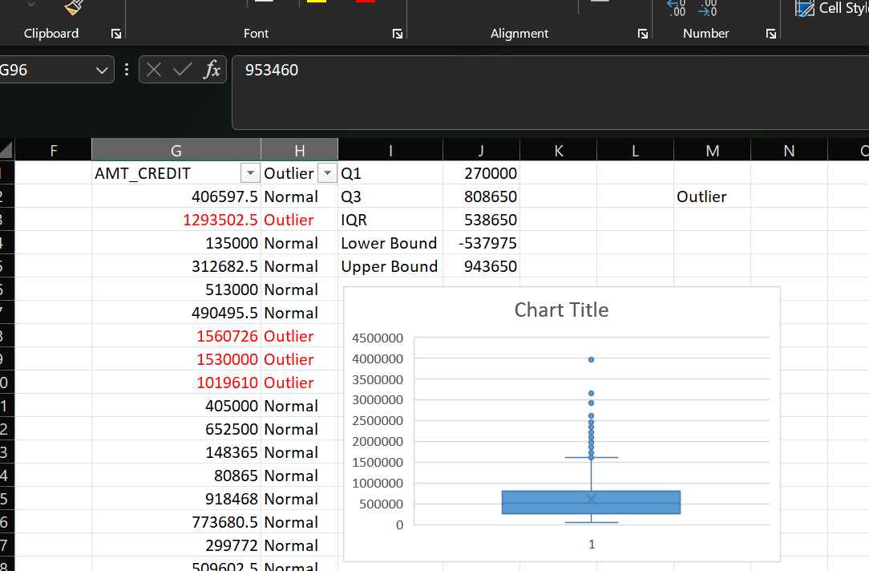

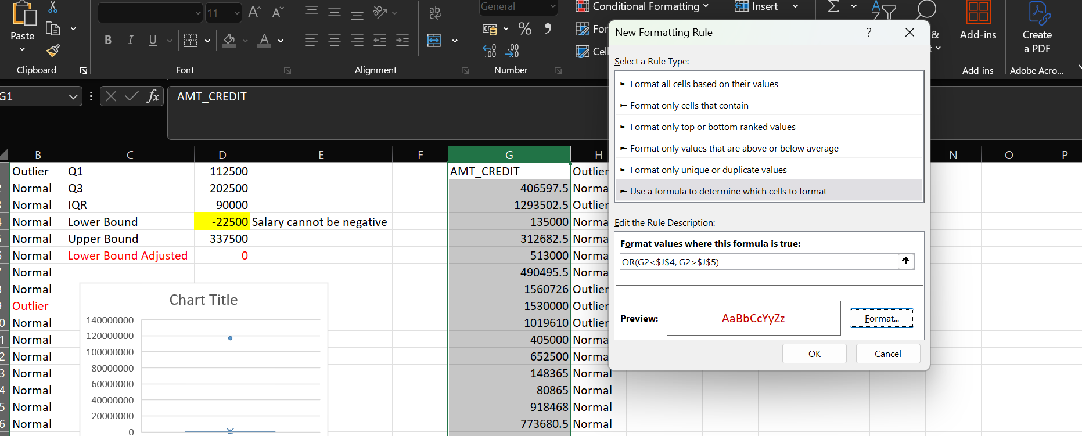

C. Analyze Data Imbalance: Data imbalance can affect the accuracy of the analysis, especially for binary classification problems. Understanding the data distribution is crucial for building reliable models.
- Task: Determine if there is data imbalance in the loan application dataset and calculate the ratio of data imbalance using Excel functions.
- Hint: Utilize Excel functions like COUNTIF and SUM to calculate the proportions of each class. Compare the class frequencies to assess data imbalance.
- Graph suggestion: Create a pie chart or bar chart to visualize the distribution of the target variable and highlight the class imbalance.

Formulas to count: Nondefaulters =COUNTIF(A2:A50000, 0)
Defaulters =COUNTIF(A2:A50000, 1)
To find percentage: Nondefaulters =D2/D4
Defaulters= =D3/D4

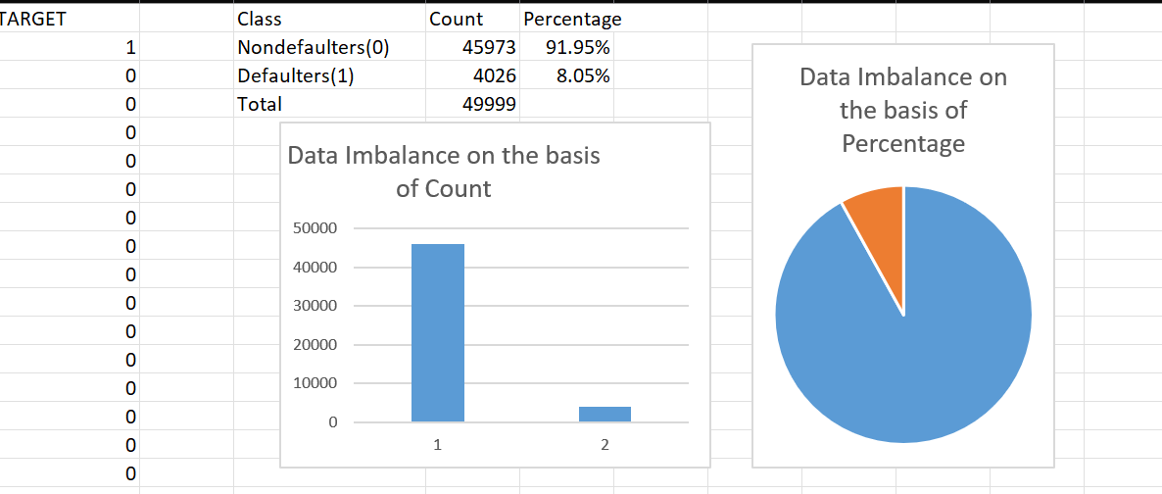

D. Perform Univariate, Segmented Univariate, and Bivariate Analysis: To gain insights into the driving factors of loan default, it is important to conduct various analyses on consumer and loan attributes.
- Task: Perform univariate analysis to understand the distribution of individual variables, segmented univariate analysis to compare variable distributions for different scenarios, and bivariate analysis to explore relationships between variables and the target variable using Excel functions and features.
- Hint: Utilize Excel functions like COUNT, AVERAGE, MEDIAN, and statistical functions for descriptive analysis. Utilize Excel features like filters, sorting, and pivot tables for segmented and bivariate analysis.
- Graph suggestion: Create histograms, bar charts, or box plots to visualize the distributions of variables. Create stacked bar charts or grouped bar charts to compare variable distributions across different scenarios. Create scatter plots or heatmaps to visualize the relationships between variables and the target variable.
Univariate Analysis
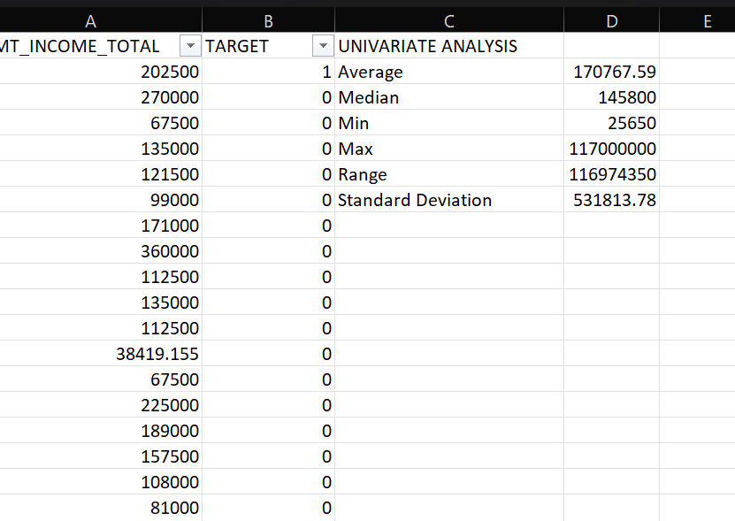

Segmented Univariate Analysis
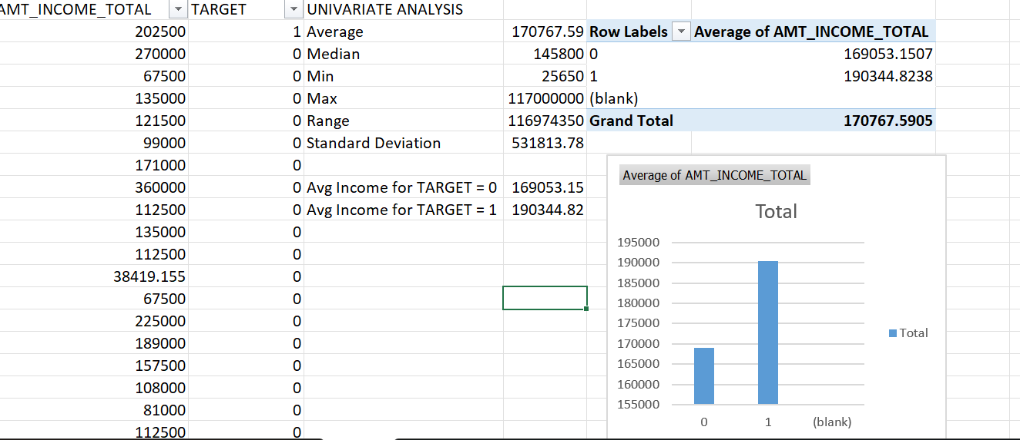
Bivariate Analysis

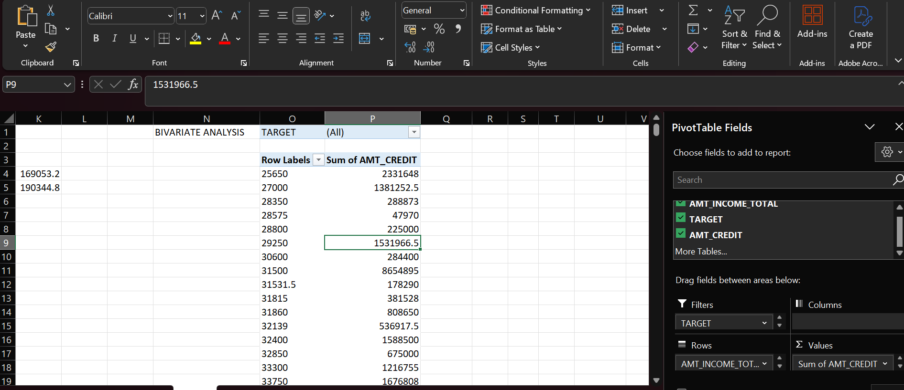

E. Identify Top Correlations for Different Scenarios: Understanding the correlation between variables and the target variable can provide insights into strong indicators of loan default.
- Task: Segment the dataset based on different scenarios (e.g., clients with payment difficulties and all other cases) and identify the top correlations for each segmented data using Excel functions.
- Hint: Utilize Excel functions like CORREL to calculate correlation coefficients between variables and the target variable within each segment. Rank the correlations to identify the top indicators of loan default for each scenario.
- Graph suggestion: Create correlation matrices or heatmaps to visualize the correlations between variables within each segment. Highlight the top correlated variables for each scenario using different colors or shading.
Correlation Matrix through Analysis ToolPak

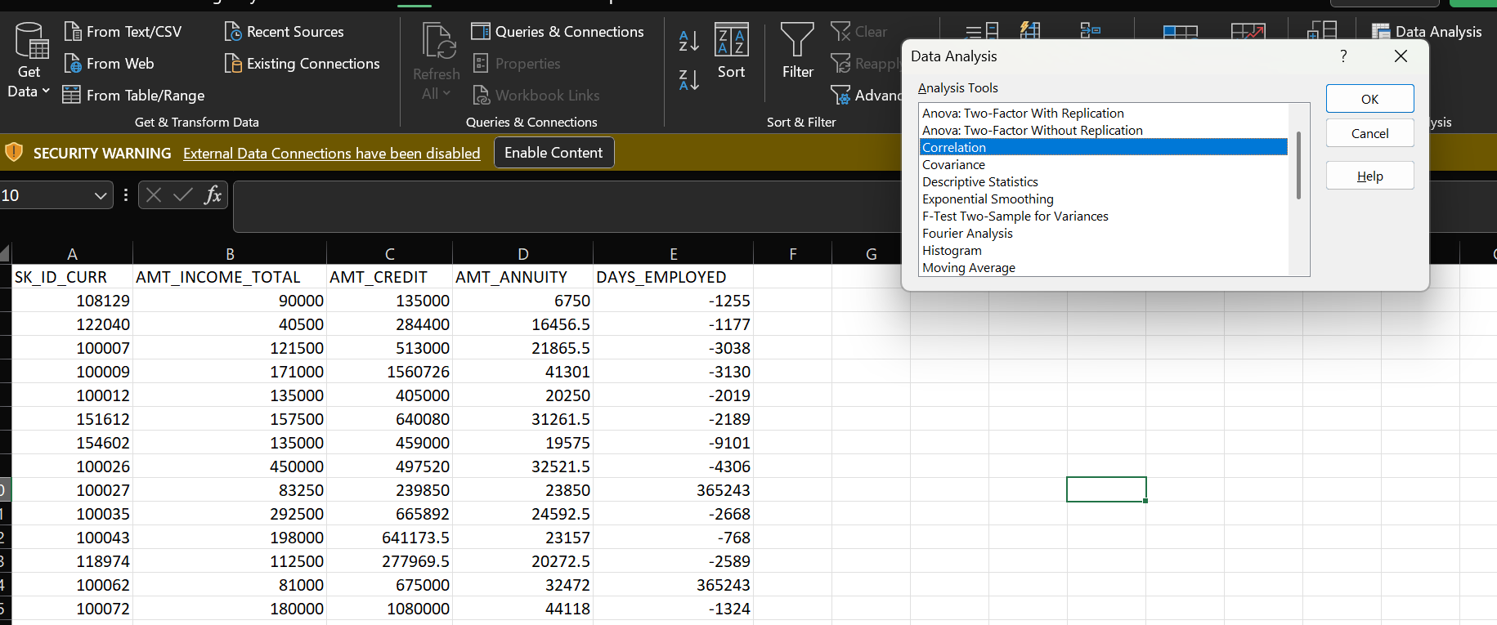

Project Description
Analyzed a bank loan dataset to identify factors influencing loan defaults and approvals using Excel-based data exploration and visualization techniques.

 | SK_ID_CURR | AMT_INCOME_TOTAL | AMT_CREDIT | AMT_ANNUITY | DAYS_EMPLOYED
SK_ID_CURR | 1
AMT_INCOME_TOTAL | -0.003049499 | 1
AMT_CREDIT | -0.000273984 | 0.069691711 | 1
AMT_ANNUITY | -0.001024893 | 0.083510231 | 0.769142584 | 1
DAYS_EMPLOYED | -0.005248541 | -0.031799531 | -0.069972353 | -0.110631166 | 1
Approach
Performed data cleaning, handled missing values, identified outliers, analyzed data imbalance, and conducted univariate, bivariate, and correlation analysis using Excel functions and pivot tables.
Tech-Stack Used
Microsoft Excel 2022 – used for data preparation, statistical analysis, and visualization through functions, pivot tables, and conditional formatting.
Insights
Identified key indicators of loan default such as income levels, age, and previous loan behavior; also found imbalance in target classes and significant outliers in financial variables.
Result
Gained practical experience in real-world financial data analysis and improved understanding of consumer risk profiling for loan decisions.

